Assignment: Data Analysis for Global Coffee Company

Find insights for a coffee company and simulate real-world requests. Continuing with the coffee database from the restoration assignment, I checked out ach scenario and posted them below to work step-by-step. First, after loading back up coffee-db and the 7 tables, I started a query to validate they all have data.
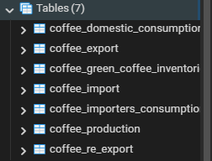
I used Query tool to select each table, get their row count to check for data populated, and use “UNION ALL” to combine all data sets. I did this because I wanted to combine/stack the datasets even if there is duplicate data rather than using just UNION. Copied the tables in order as pictured above.

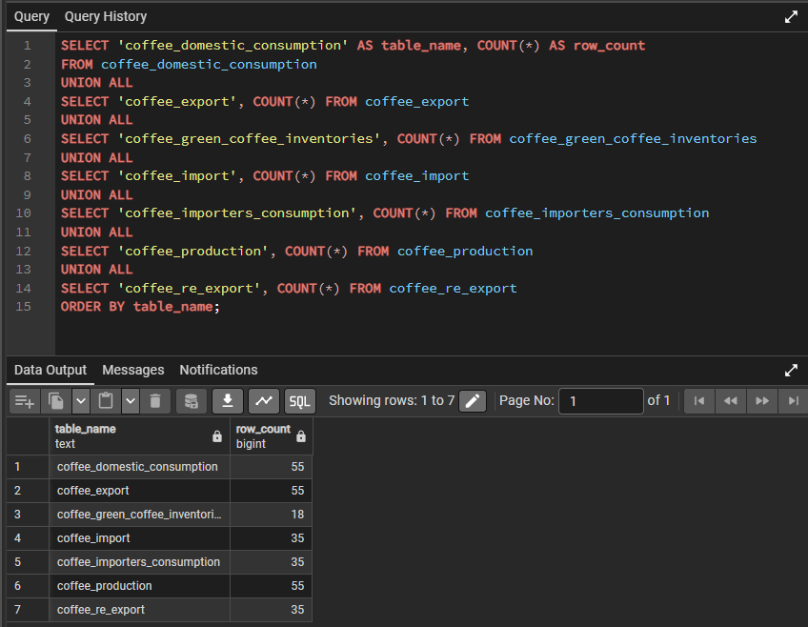
Rows are populated with data so should check column structure of coffee_production table (for example)

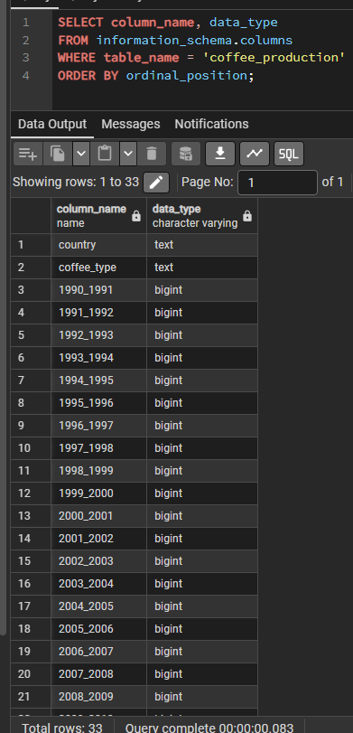

First check columns of table when switching to other tables (i.e coffee_importers_consumption) and ordered by ordinal position left to right to be easier to read:
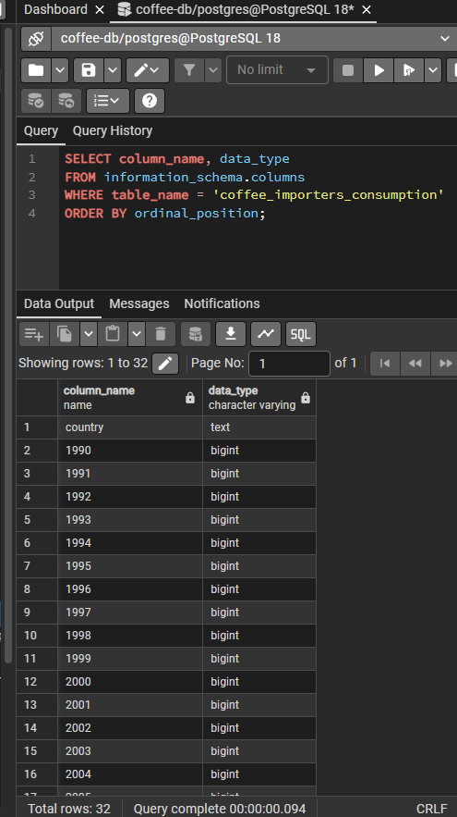

Country columns + column for years 1990-2019
Preview first 3 rows
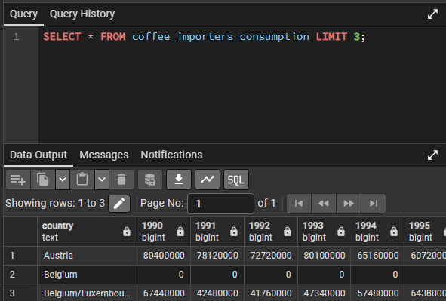

In this case, Belgium does not have data from years 1990-1998. Practice validating top 10 importers without using unnecessary column names for ranking (below in resources for RANK function):
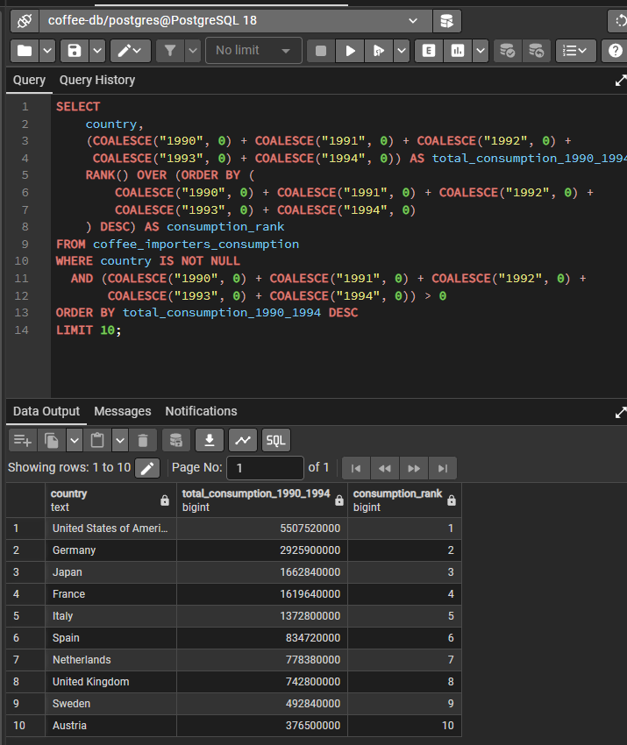

REQUIREMENTS:
- A detailed SQL query or a series of queries to retrieve the required information.
- CSV output or screenshot
- A brief analysis of the findings

Resources
https://www.postgresqltutorial.com/postgresql-tutorial/postgresql-coalesce/
https://www.postgresqltutorial.com/postgresql-tutorial/postgresql-cte/
https://www.postgresqltutorial.com/postgresql-window-function/
https://www.commandprompt.com/education/postgresql-rank-function-with-examples/
https://www.postgresqltutorial.com/postgresql-window-function/postgresql-rank-function/
https://www.postgresqltutorial.com/postgresql-window-function/postgresql-dense_rank-function/
Bonus: combining multiple queries

Data Requests

1. Identifying Top Exporter (1990-1994): .SQL Query File and .CSV File
Scenario: The company is looking to understand historical trends in coffee exports.
Task: Determine which country exported the most coffee cumulatively from 1990 to 1994.
Expected Output: A report stating the top exporting country along with the total export volume for the specified period.
To find the top exporter, we must use the coffee_export table and choose the years 1990-1994.
Will need to take total exports and convert to decimal so that a percentage can be calculated (type casting to numeric from integer)

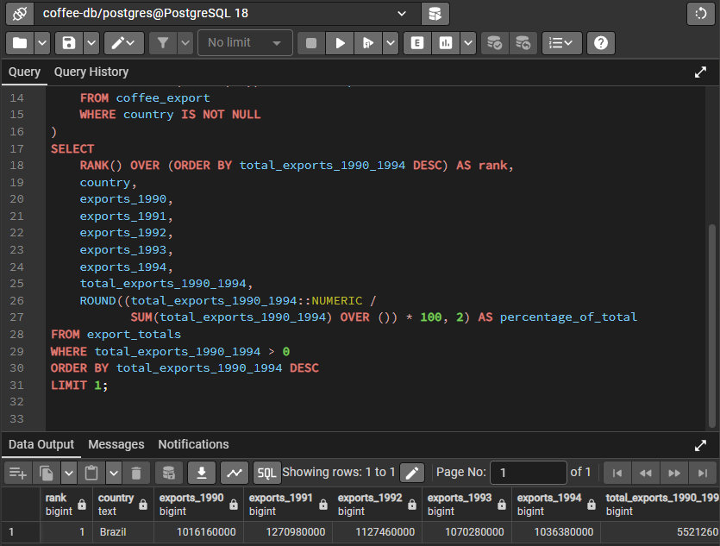
Here is a report year by year 1990-1994 with top 3 countries and their percentage of total with total_exports_1990_1994, and below is output in .csv file
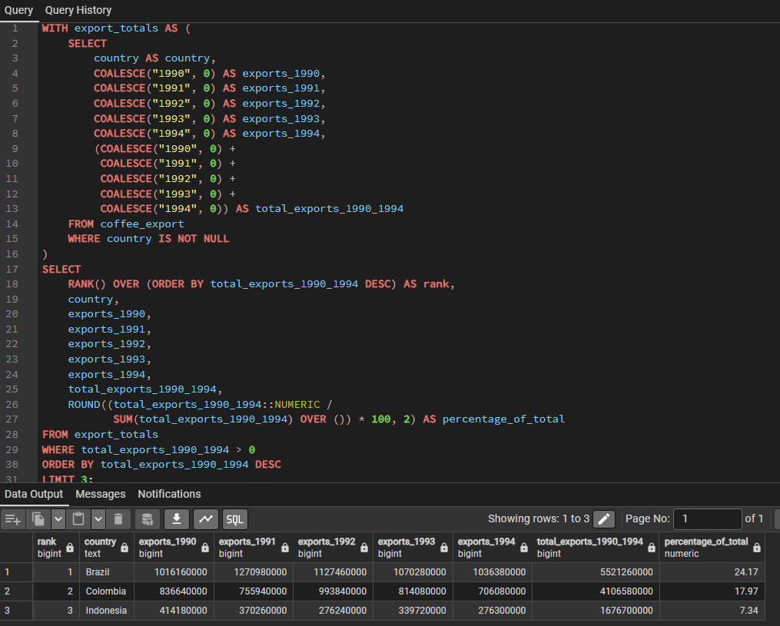
Output:
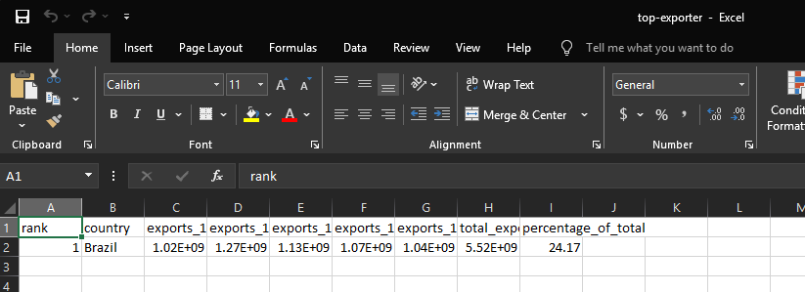

2. Top Coffee Producers (1999-2004): .SQL Query File and .CSV File
Scenario: To plan future coffee sourcing strategies, the company needs to identify key coffee-producing countries.
Task: Find the five countries with the most coffee production from 1999 to 2004.
Expected Output: A table listing the countries, their rank, and their combined production from 1999 to 2004.
From coffee_production table, I will be using similar syntax to the Data Request 1 query. Find top 5 countries with production between 1999-2004. Countries, rank, and combined production.
Column structure
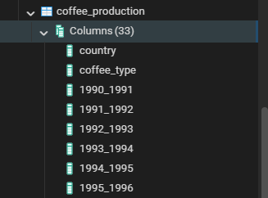
TOP 5
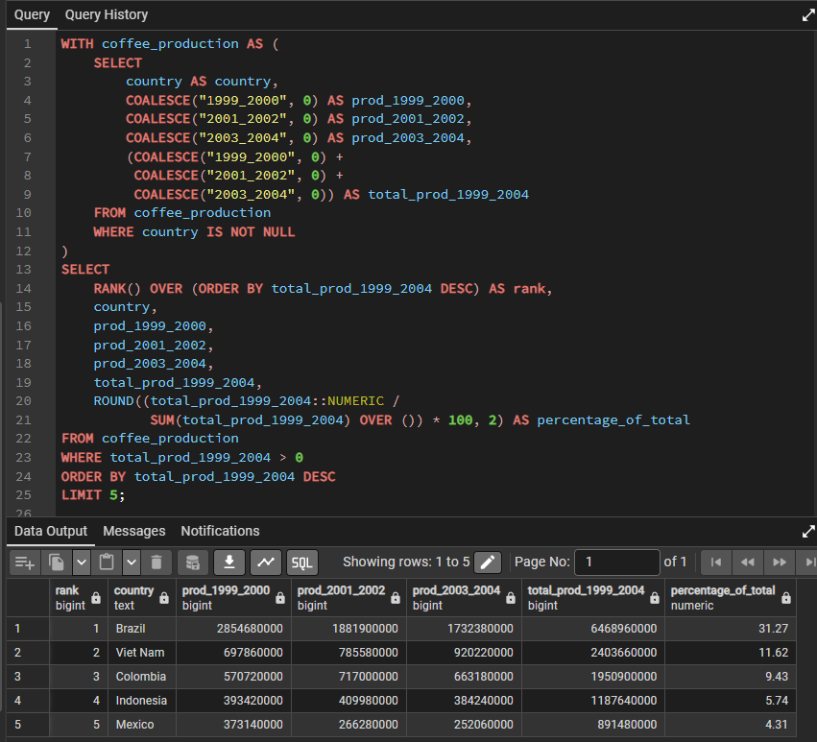
Calculate 5 year cumulative production as total_production, then rank and calc percentage_of_total (total / () * 100, 2).
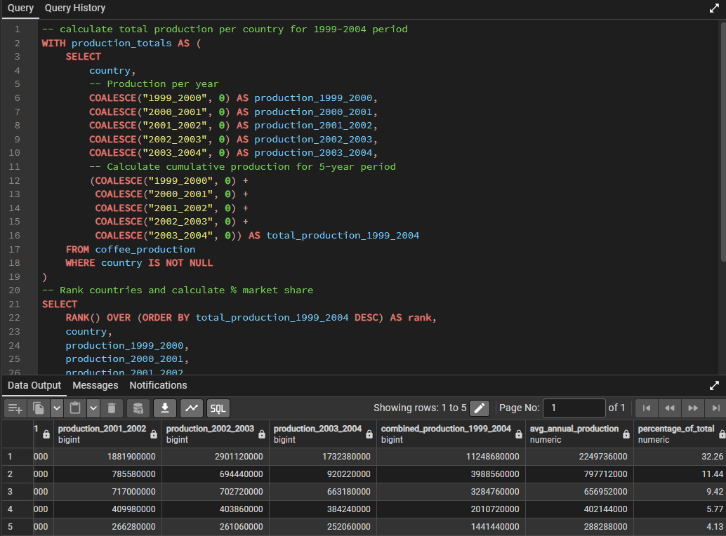
Output: Brazil (11248680000), Vietnam (3988560000), Colombia (3284760000), Indonesia (2010720000), Mexico (1441440000)
Output in .csv file:
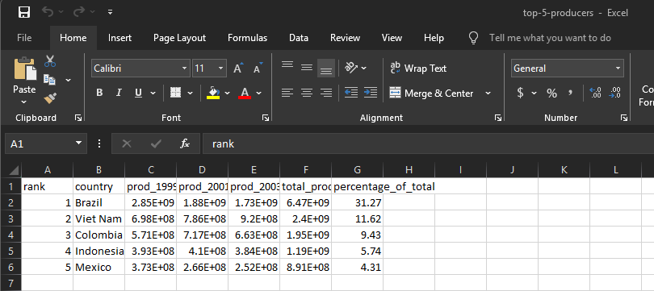

3. Second Highest Coffee Production by Type (1990-1994): .SQL Query File and .CSV File
Scenario: Understanding the diversity in coffee production is crucial for market analysis.
Task: Identify countries with the second highest coffee production for each coffee type from 1990-1994. Note that there can be multiple countries tied for the second place.
Expected Output: A list of coffee types along with the corresponding countries that ranked second in production for each type.
2nd highest coffee production, sorted by type between years 1990-1994, handle nulls with COALESCE() as well as DENSE_RANK() then filter for 2nd place only / change column names
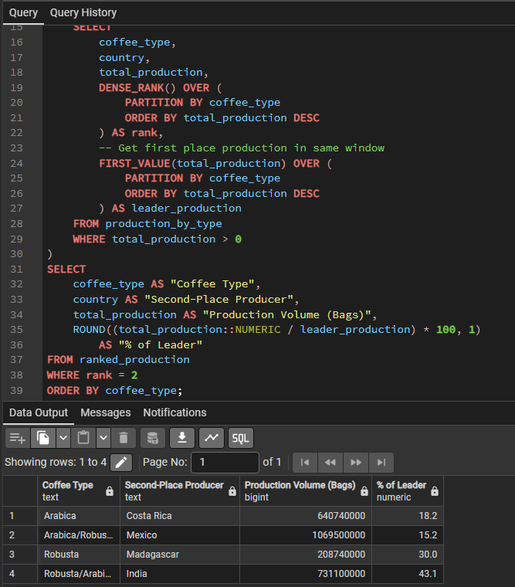
Output in .csv file:
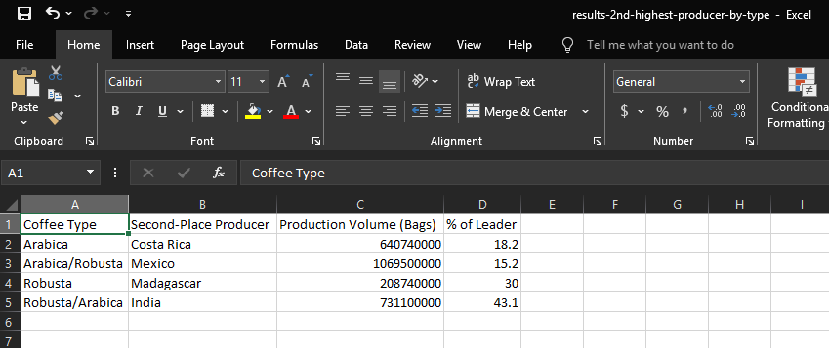

4. Top Five Countries in Combined Exports and Imports (1995-2000): .SQL Query File and .CSV file
Scenario: The company is assessing its global trade footprint.
Task: Name the top five countries with the most combined coffee export and import volume between 1995 to 2000.
Expected Output: A CSV file containing columns for country, export volume, import volume, and total combined volume for the specified period.
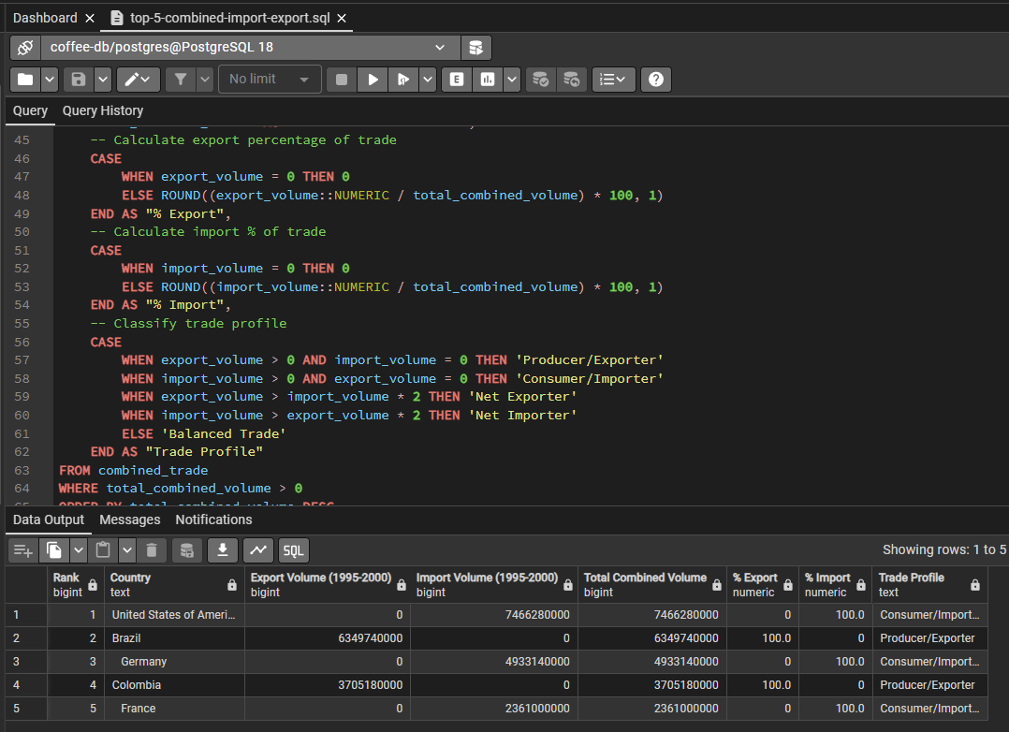
Output in .csv file:
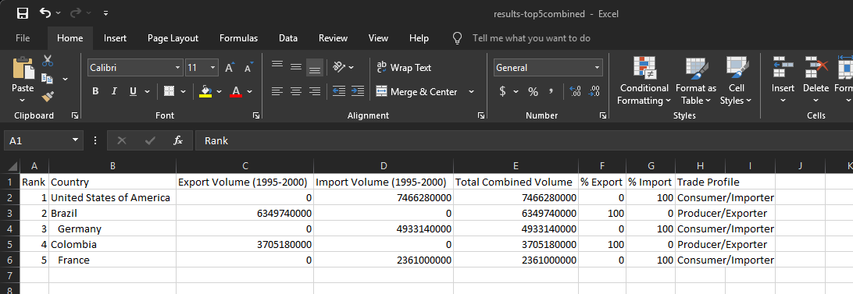

5. Import Analysis with Country of Origin:
Scenario: For supply chain optimization, the company seeks detailed import data.
Task: Attempt to show imports for every country, including the country of origin for those imports, ranked by import volume.
Expected Output: Explain why this data might not be retrievable from the current database structure. Suggest alternative methods or additional data that could be used to fulfill this request.
I do not see origin data from the coffee_import table or the destination of the orders. Without this, I cannot track where the imports come from but I can see which countries import coffee. You can make some inferences from the data we do have access to, but cannot link destinations (exact trade partnerships or routes).

